**Honor Board Accord: Fair or Foul?**

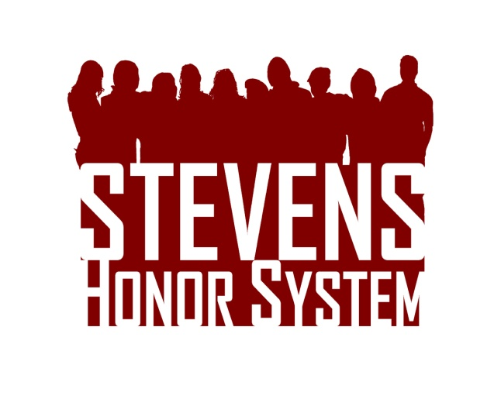Read the fake case presented to the Honor Board and determine whether a violation has occurred and what penalties should be assigned. Please support your reasoning. Visit [stevens.edu/honor](http://stevens.edu/honor) for the Honor System Bylaws and Penalty Matrix.  Drop your answers in Stevens mailbox S-0192 or email them to [honor@stevens.edu](mailto:honor@stevens.edu) by March 31st. The top response will receive a $50 Visa gift card!

Groups of three are asked to complete a lab in an Engineering Design III class. For the experiment, one person copies down the data and emails it out to the other two group mates. It is discovered that the student who sent out the data intentionally changed some of the numbers he emailed to sabotage those in his group. As a result, the individual write-ups submitted by the two group mates contradicted the information taught in class. Should any students be found guilty of an Honor System violation? If yes, what penalty should be assigned?